
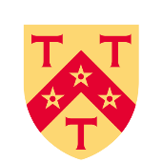
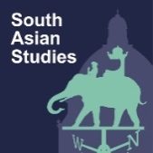
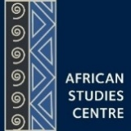

South Asia-Africa Seminar Series

Hilary Term 2026

In HT2026, the weekly Modern South Asia Seminar Series and the African Studies Seminar Series will be jointly convened as the South Asia-Africa Seminar Series. The goal of this Series is to create opportunities for a cross-regional encounter of scholars, research agendas, epistemologies, and field sites across South Asia and Africa via a different lens or topic every week.

Seminars to be held Tuesdays from 2 to 3.30pm in the Pavilion Room, St Antony’s College

Week 1 Anti-caste and Anti-imperial Political Thought
Tue 20 Jan Karthick Ram Manoharan (Cambridge) and Amber Murrey (Oxford)

Week 2 Talking about Unfree Labour
Tue 27 Jan Bhanupriya Rao (Behanbox) and Michael Odijie (Oxford)
Week 3 Insurgency, Conflict and Governance
Tue 3 Feb Paula Cristina Roque (Intelwatch) in conversation with Alpa Shah (Oxford)

Week 4 Negotiating Sovereignty in Global China Relations
Tue 10 Feb Miriam Driessen (Oxford) and Thiruni Kelegama (Oxford)

Week 5 Gen Z Revolutions
Tue 17 Feb Velomahanina Razakamaharavo (Reading) and David Gellner & Krishna Adhikari (Oxford)

Week 6 The Politics of Digital Interventions
Tue 24 Feb Nafis A Hasan (Amsterdam) and Thomas Neumark (Oslo)
Week 7 Southern Urbanisms, Migration and Belonging
Tue 3 March Bani Gill (Tubingen) and Elisa Tamburo (Havard & Oxford)

Week 8 The Politics and Technologies of Measurement
Tue 10 March Shankar Nair (Oxford) and Rachel King (UCL)

All are welcome
Convenors: Janaki Srinivasan & Rebekah Lee

Enquiries: asian@sant.ox.ac.uk or 01865-274559
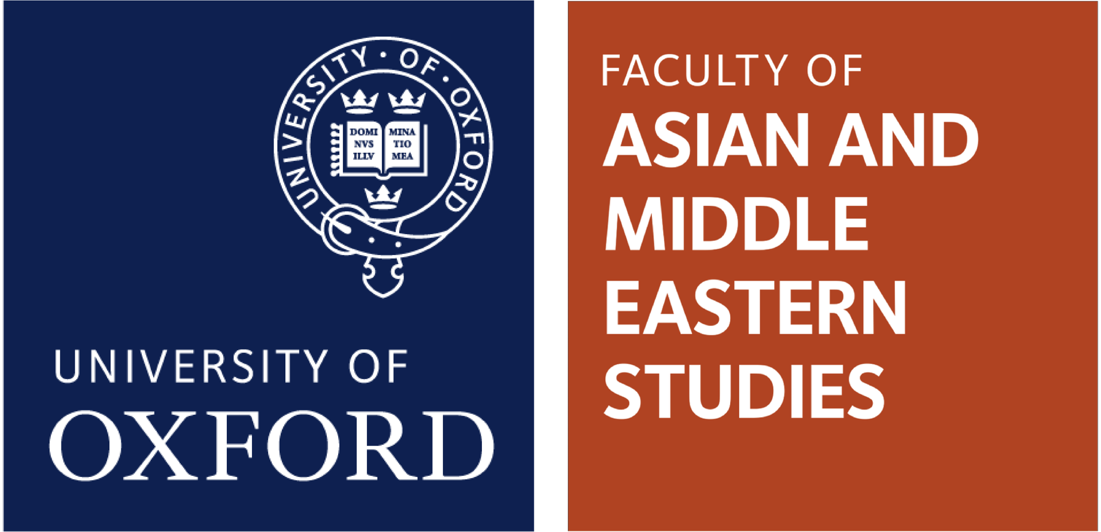
Supported by the Asian Studies Centre of St Antony’s College, the Contemporary South Asian Studies Programme and the African Studies Centre at the Oxford School of Global and Area Studies (OSGA), and the Faculty of Asian and Middle Eastern Studies.

